Contraception Counseling Workshop

This workshop was intended to teach contraception and counseling to 2nd year medical students in a way that prepares them for clinical encounters.

Jody Steinauer, MD, MAS
Micki Baron, MD

Learning Objectives:
By the end of the session, learners will be able to:
- Review basic information about contraceptive methods, specifically LARC methods as well as special considerations for medically complex and postpartum women
- Introduce a shared decision-making approach to counseling
- Allow students an opportunity to practice LARC insertion techniques on models

Curriculum components:
- Session preparation – students were expected to watch a 25-minute online video module and read the syllabus chapter covering basic medical information about contraception.

- Contraception cases – in a large group session, students reviewed clinical cases with a contraception expert using interactive Poll Everywhere questions, “think-pair-share” prompts, and CDC Medical Eligibility
Criteria.

Case 1 | Case 2
31 yo healthy G1P1 on postpartum day 2 | 25 yo G0 with history of obesity and a remote DVT

- Contraception stations – students could handle different methods and learn LARC insertion techniques.

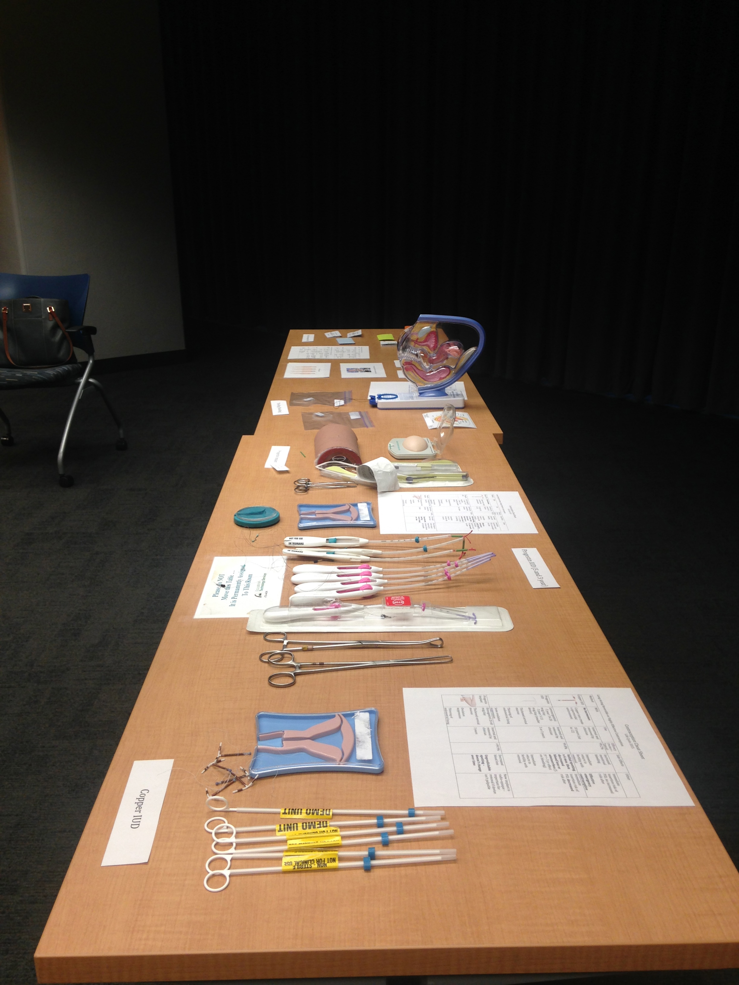

Evaluation:
- We obtained usage data for the online module through the iRocket page.
- Evaluation through an anonymous questionnaire.
- Outcome measurements:
  - Attendance – taken without student names
  - Duration of preparation – estimated by students in survey
  - Session interactivity – True/False response comparison with traditional lecture
  - Student understanding and confidence – rated as 1-3 scale as compared to feelings before the session.

RECOMMENDED Additional Reading
- Bedsider: http://bedsider.org/methods. Designed for the general public, it is a wonderful resource for information about contraception and sexuality.
- A Pocket Guide to Managing Contraception. This information-packed, well-informed guide for clinicians is freely available on-line at https://www.managingcontraception.com/files/MC-2012.pdf.

